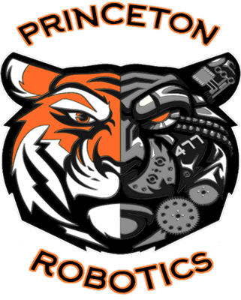

**Fundraisers and Events (2025–2026)**

*This is a living document, subject to change and will be continually updated.*  
**Last Updated: 09/07/2025**

**September 2025**

**September 10 – Mandatory Parent and Student Meeting (Princeton Middle School)**

* **IQ Programs:** 5:15 PM
* **VRC Programs:** 6:30 PM

**September 11 – October 4**

* **Fundraiser:** Grand Champion Meats Sales

**October 2025**

**October 7**

* **Fundraiser:** Nothing Bundt Cake handout (distributed at practice)

**October 24**

* **Event:** Grand Champion Meats Pick-Up
* **Pick-Up Location:** TBD

**November 2025**

**November 11 (5:00–8:00 PM)**

* **Fundraiser Night:** Pizza Barn
* **Notes:**
  + Volunteers Needed
  + **Deadline:** Money and order forms due for Nothing Bundt Cakes
  + Drop-off at Pizza Barn or at practice

**November 20 – Time TBD**

* **Event:** Nothing Bundt Cakes Pick-Up
* **Pick-Up Location:** TBD

**January 2026**

**January Date TBD**

* **Fundraiser:** Gun Raffle Ticket Sales

**January 10 (7:00 AM – 5:00 PM)**

* **Event:** IQ Rum River Rumble Tournament
* **Location:** Princeton High School
* **Volunteers Needed**

**February 2026**

**February 3–17**

* **Fundraiser:** Cards for Cause
* **Note:** Online ordering only (link via Remind and Facebook)

**February 7 (7:00 AM – 5:00 PM)**

* **Event:** V5RC Rum River Rumble Tournaments
* **Locations:** Princeton High School, Middle School, and High School

**February 26 (All Day)**

* **Fundraiser:** Papa Murphy’s Fundraising Day

**March 2026**

**March 5–6**

* **Event:** V5RC State Robotics Tournament
* **Location:** St. Cloud

**March 7**

* **Event:** IQ State Robotics Tournament
* **Location:** St. Cloud

**March 16–18**

* **Event:** Create US Open – High School Division
* **Location:** Council Bluffs, IA

**March 19–21**

* **Event:** Create US Open – Middle School Division
* **Location:** Council Bluffs, IA

**March 26–28**

* **Event:** Create US Open – IQ Division
* **Location:** Council Bluffs, IA

**April 2026**

**April 21–24**

* **Event:** VEX Worlds – High School
* **Location:** St. Louis, MO

**April 25–27**

* **Event:** VEX Worlds – Middle School
* **Location:** St. Louis, MO

**April 28–30**

* **Event:** VEX Worlds – IQ Division
* **Location:** St. Louis, MO

**May 2026**

* **Event:** End of Season Party
* **Date:** TBD